**Puppet Notes – 2/22/19**

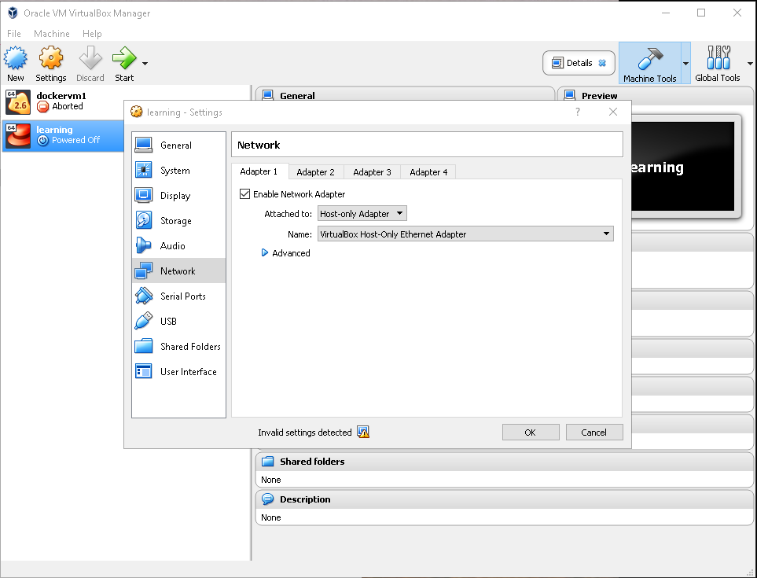

**Change Adaptor Settings – Attached to: Host-Only Adaptor 🡪 Click OK**

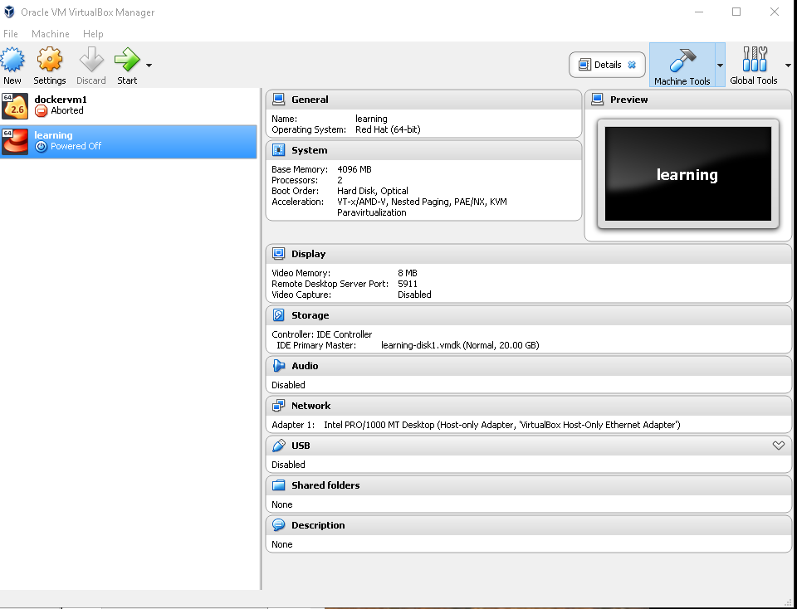

**On the green Start Arrow – click**

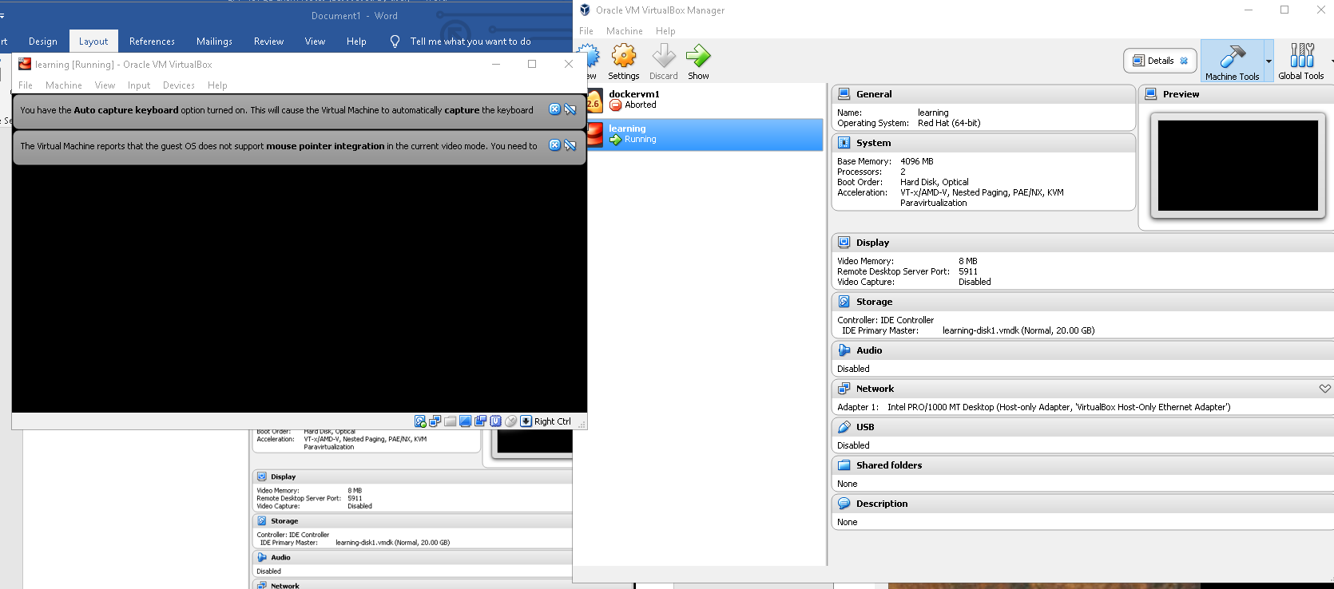

**Remember the IP Address**

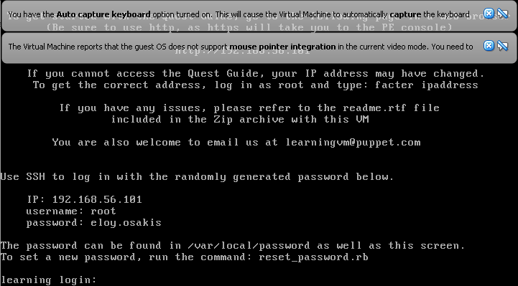

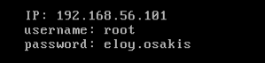

**NOTE: if you see the following window pop up 🡪**

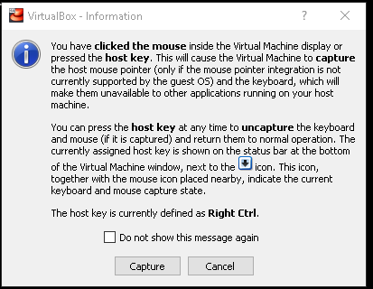

**Type cancel; If mouse stops – click right control button on keypad or click on button in window. To get a larger window with scrolling type 192.168.56.101:9091 in browser**

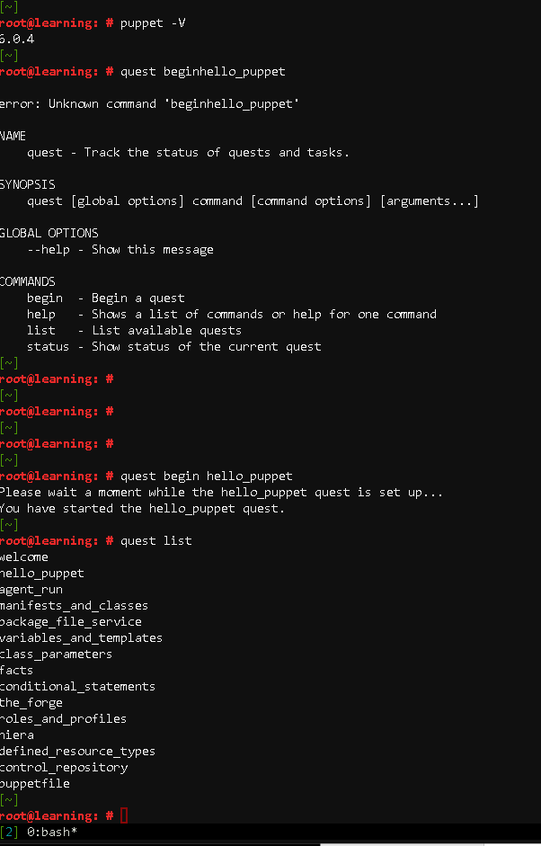

**Certificate Issues – SSL**

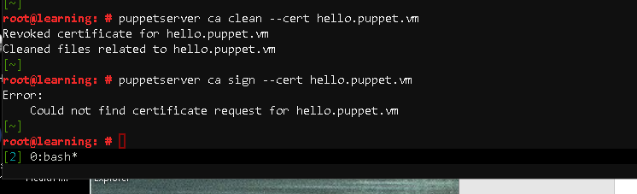

**Resource Information:**

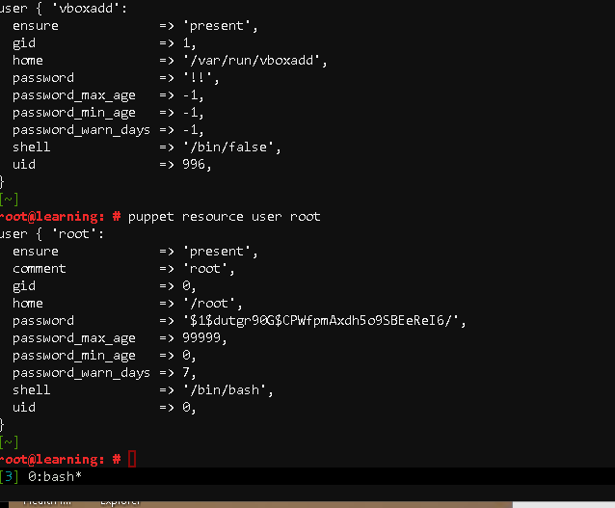

**Root exists – now let’s try user that does not exist.**

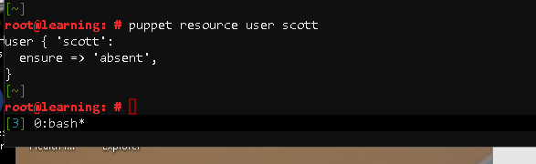

**Puppet resource user | more**

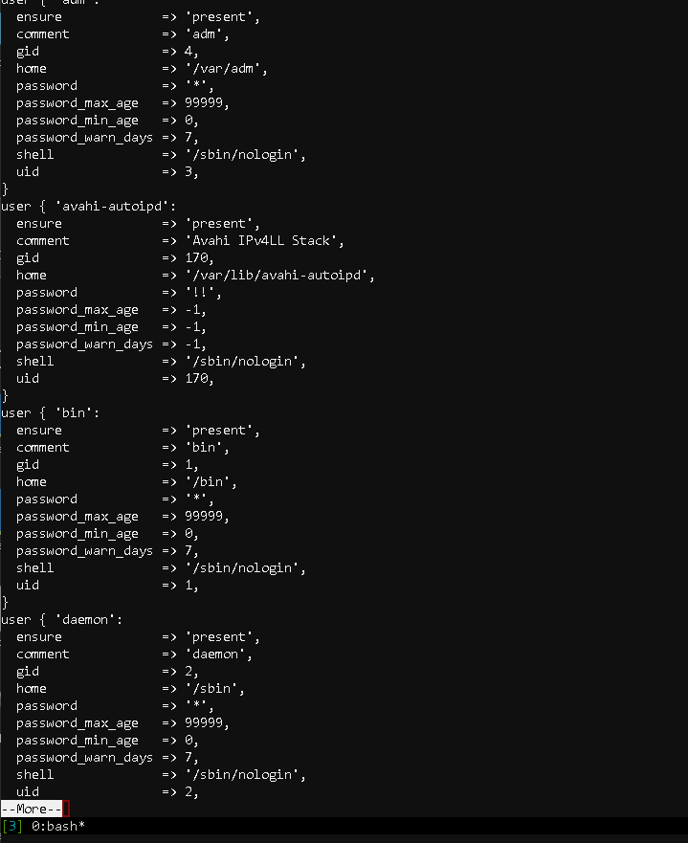

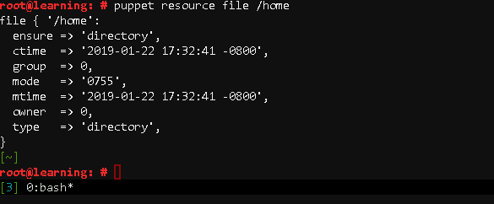

**Ex. Check on a package – http**

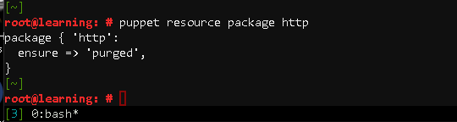

**Ex. http does not exist – purged.**

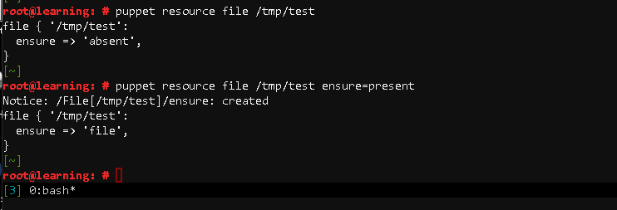

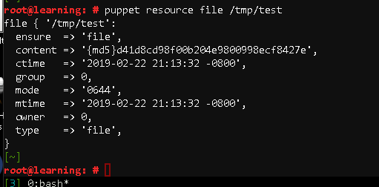

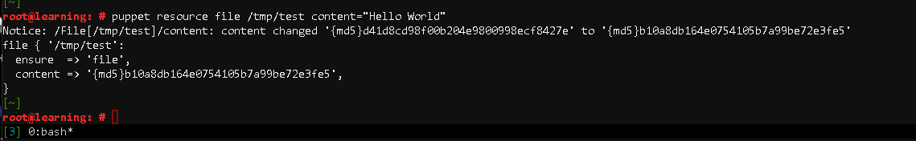

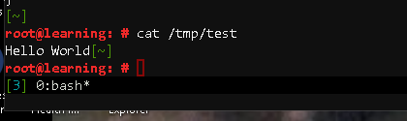

**root@learning: #** puppet resource file /tmp/test ensure=absentNotice: /File[/tmp/test]/ensure: removedfile { '/tmp/test': ensure => 'absent',}[~]

